**LAB EXAM**

**MS.Net Technologies**

1. **Create a menu driven C# application to interact with the database. You have to insert data into &quot;Students&quot; table and retrieve a list of all the students from the Students table and display their names, roll numbers, and their marks. In the above question, perform update and delete operations as well.**

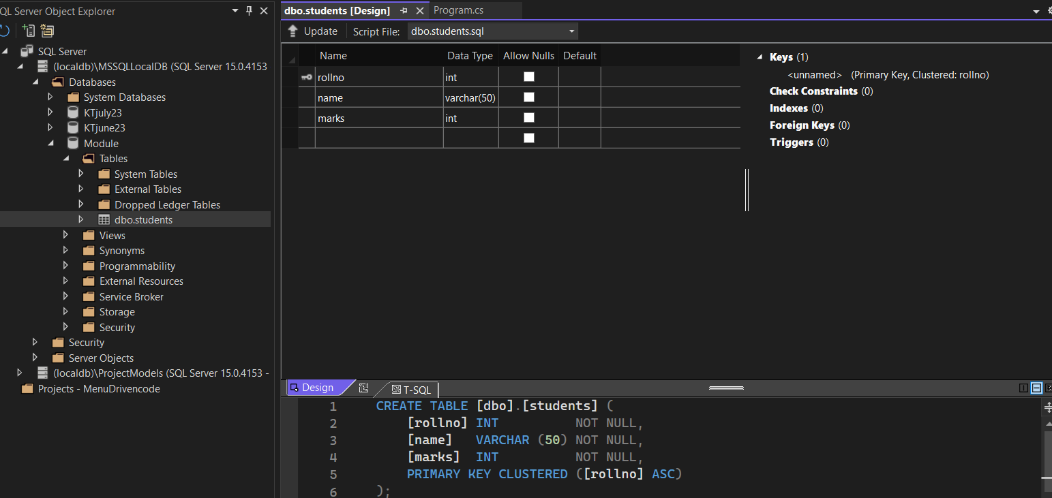

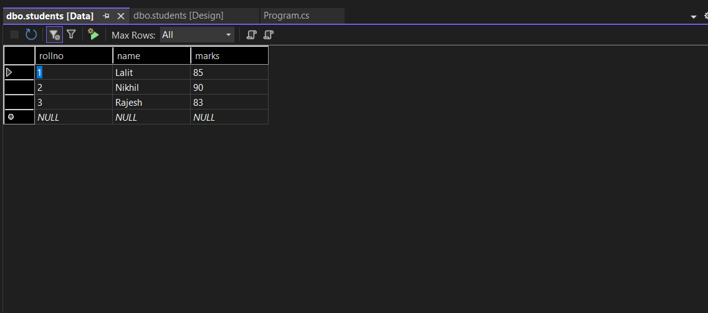

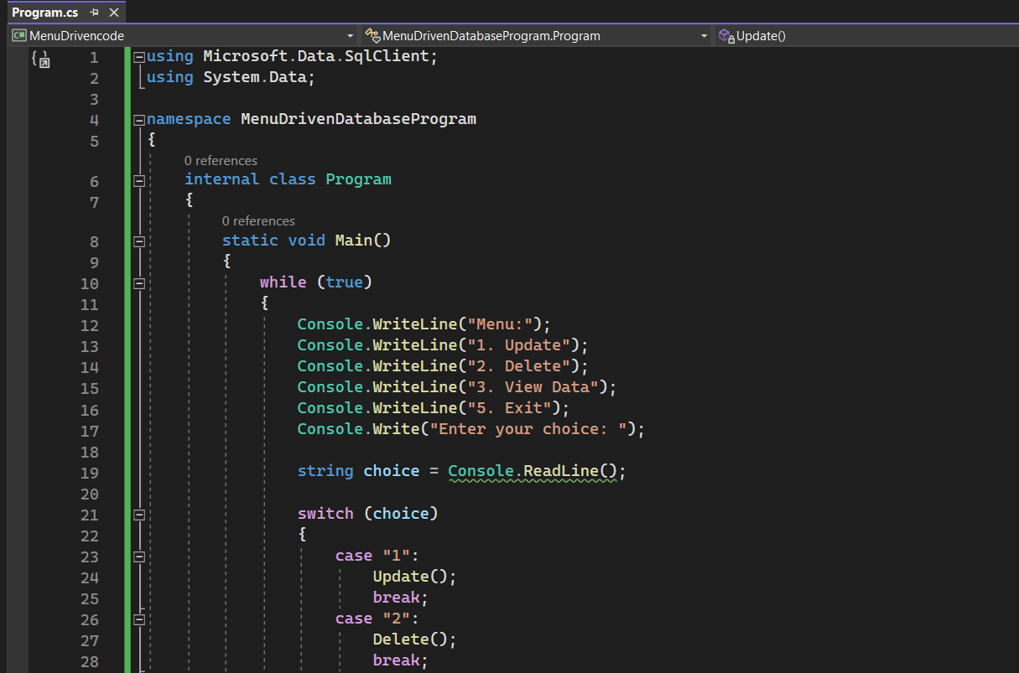

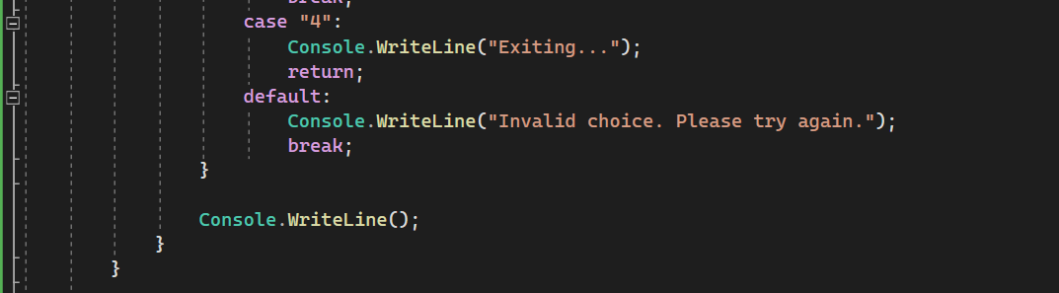

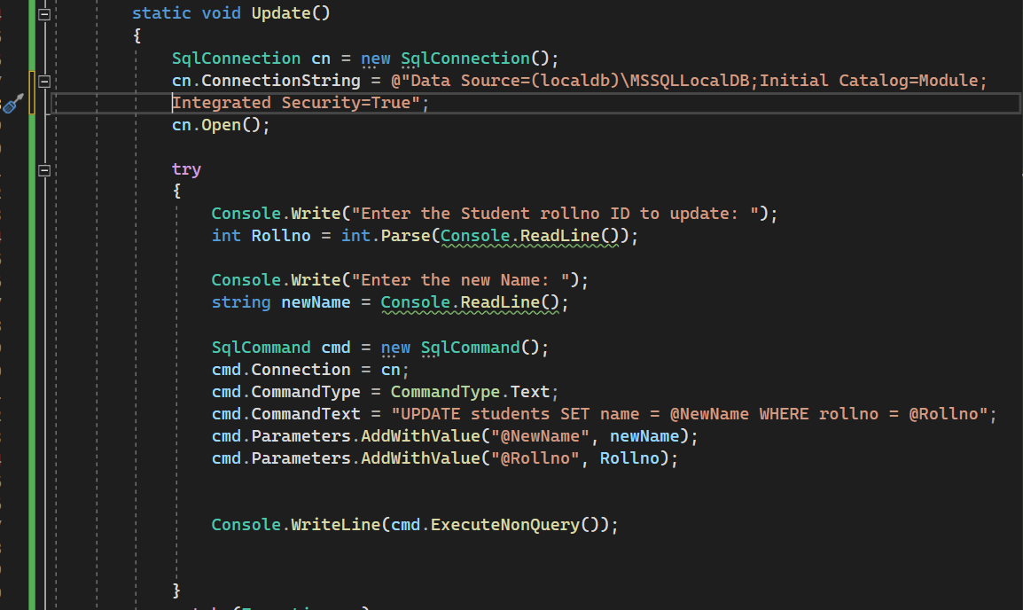



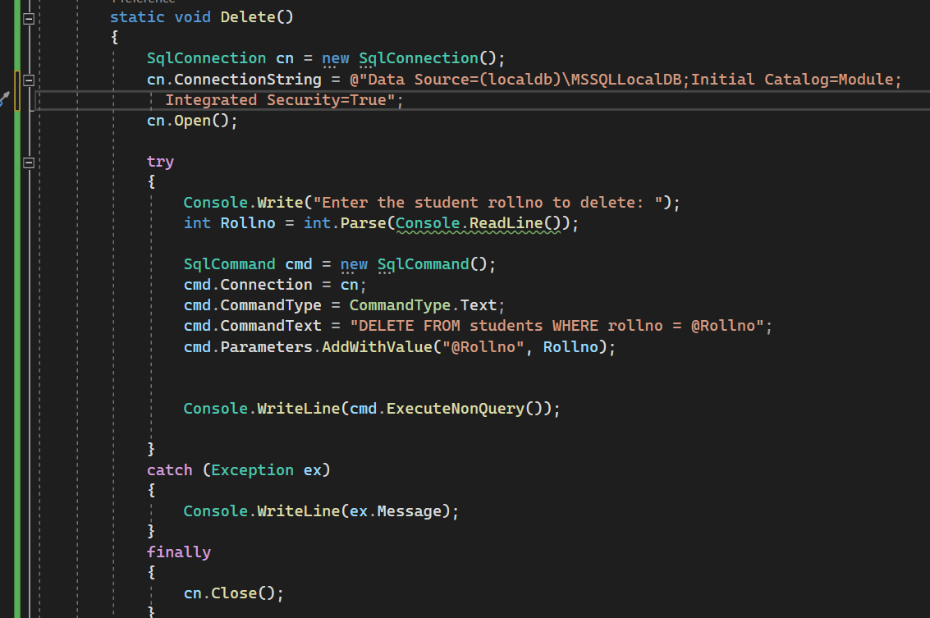

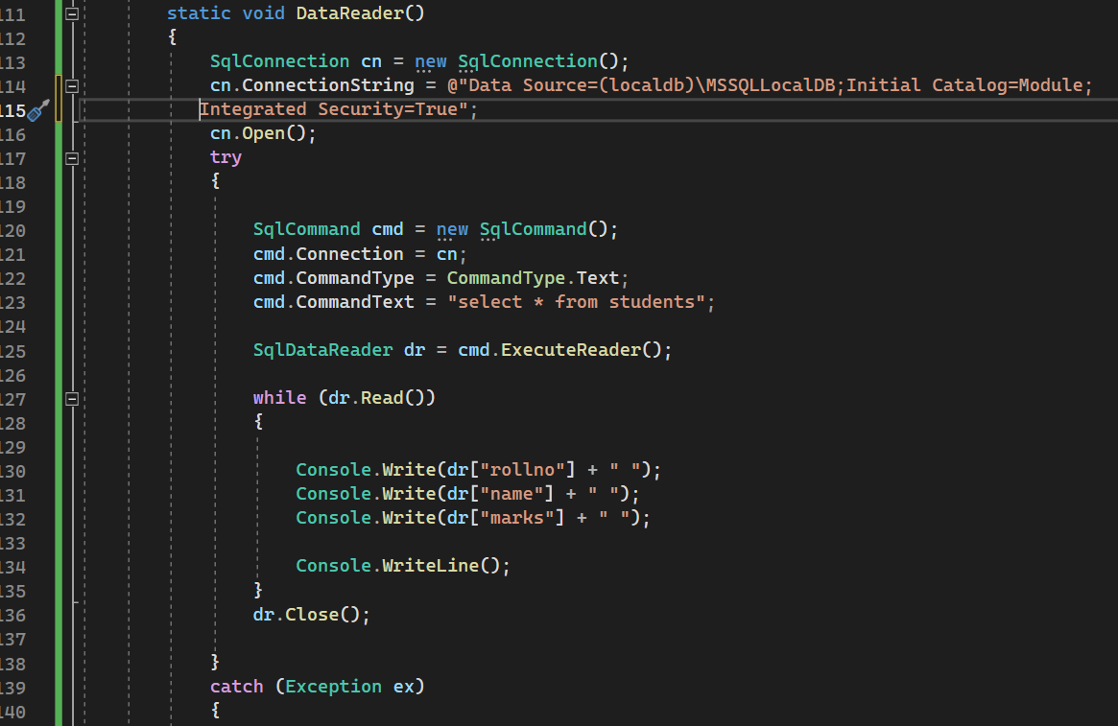

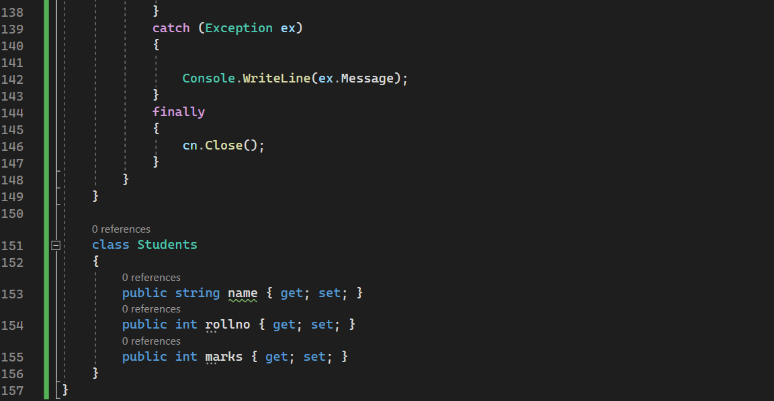

**Update and read**

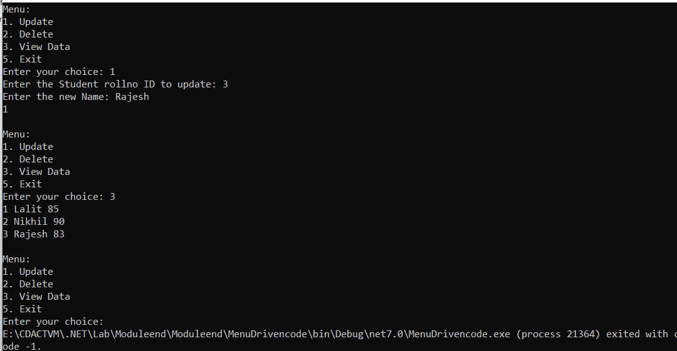

**Delete and read**

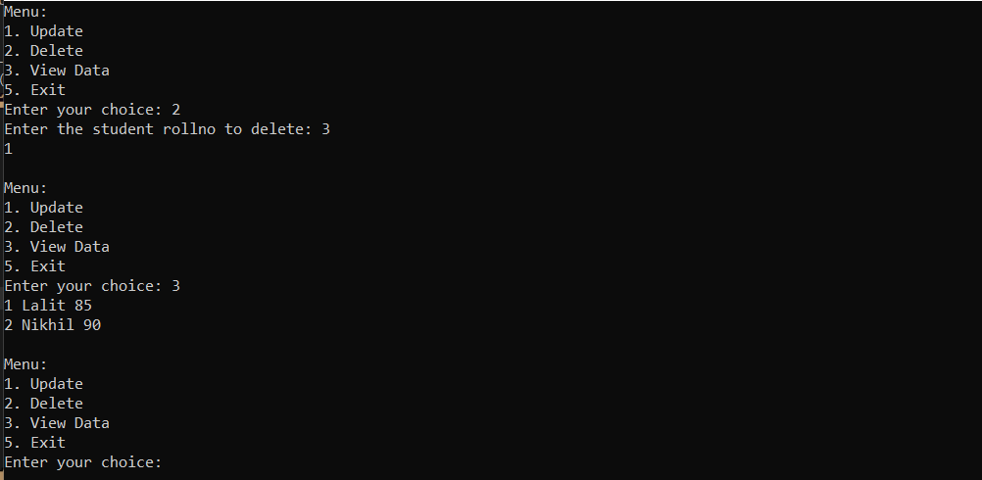

using Microsoft.Data.SqlClient;

using System.Data;

namespace MenuDrivenDatabaseProgram

{

internal class Program

{

static void Main()

{

while (true)

{

Console.WriteLine("Menu:");

Console.WriteLine("1. Update");

Console.WriteLine("2. Delete");

Console.WriteLine("3. View Data");

Console.WriteLine("5. Exit");

Console.Write("Enter your choice: ");

string choice = Console.ReadLine();

switch (choice)

{

case "1":

Update();

break;

case "2":

Delete();

break;

case "3":

DataReader();

break;

case "4":

Console.WriteLine("Exiting...");

return;

default:

Console.WriteLine("Invalid choice. Please try again.");

break;

}

Console.WriteLine();

}

}

static void Update()

{

SqlConnection cn = new SqlConnection();

cn.ConnectionString = @"Data Source=(localdb)\MSSQLLocalDB;Initial Catalog=Module;

Integrated Security=True";

cn.Open();

try

{

Console.Write("Enter the Student rollno ID to update: ");

int Rollno = int.Parse(Console.ReadLine());

Console.Write("Enter the new Name: ");

string newName = Console.ReadLine();

SqlCommand cmd = new SqlCommand();

cmd.Connection = cn;

cmd.CommandType = CommandType.Text;

cmd.CommandText = "UPDATE students SET name = @NewName WHERE rollno = @Rollno";

cmd.Parameters.AddWithValue("@NewName", newName);

cmd.Parameters.AddWithValue("@Rollno", Rollno);

Console.WriteLine(cmd.ExecuteNonQuery());

}

catch (Exception ex)

{

Console.WriteLine(ex.Message);

}

finally

{

cn.Close();

}

}

static void Delete()

{

SqlConnection cn = new SqlConnection();

cn.ConnectionString = @"Data Source=(localdb)\MSSQLLocalDB;Initial Catalog=Module;

Integrated Security=True";

cn.Open();

try

{

Console.Write("Enter the student rollno to delete: ");

int Rollno = int.Parse(Console.ReadLine());

SqlCommand cmd = new SqlCommand();

cmd.Connection = cn;

cmd.CommandType = CommandType.Text;

cmd.CommandText = "DELETE FROM students WHERE rollno = @Rollno";

cmd.Parameters.AddWithValue("@Rollno", Rollno);

Console.WriteLine(cmd.ExecuteNonQuery());

}

catch (Exception ex)

{

Console.WriteLine(ex.Message);

}

finally

{

cn.Close();

}

}

static void DataReader()

{

SqlConnection cn = new SqlConnection();

cn.ConnectionString = @"Data Source=(localdb)\MSSQLLocalDB;Initial Catalog=Module;

Integrated Security=True";

cn.Open();

try

{

SqlCommand cmd = new SqlCommand();

cmd.Connection = cn;

cmd.CommandType = CommandType.Text;

cmd.CommandText = "select * from students";

SqlDataReader dr = cmd.ExecuteReader();

while (dr.Read())

{

Console.Write(dr["rollno"] + " ");

Console.Write(dr["name"] + " ");

Console.Write(dr["marks"] + " ");

Console.WriteLine();

}

dr.Close();

}

catch (Exception ex)

{

Console.WriteLine(ex.Message);

}

finally

{

cn.Close();

}

}

}

class Students

{

public string name { get; set; }

public int rollno { get; set; }

public int marks { get; set; }

}

}

1. **Create a model class named Car. Add an Index by using model binding, perform create, read update and Delete operations for details such as CarId, Name, bhp, cc, fuel tank and fuelEconomy.**

